
HRMIS
Developer’s Guide
Document Change History

Version Number | Date | Contributor | Description
V1.0 | 26-08-2020 | Jeswin Chacko P A

TABLE OF CONTENTS
1 Introduction 3
2 Project Setup 3
2.1 Prerequisite 3
2.2 Steps to Import Project 3
2.3 Database Setup 3
2.3.1 Create connection in MYSQL 3
2.4 Run The Project 4
3 Important Files and its responsibilities 4
3.1 Application properties 4
4 Building the project 4
5 Application Deployment 5
6 DB Structure 5
6.1 Tables 6
7 Code Structure 6
7.1 Java Code 6
7.2 UI code 7

Introduction
HRMIS is an online system created for The Indocosmo Systems Pvt. Ltd. , Kochi, for people to forward,accept,reject & cancel their leave requests through an automated systemk. The system can be installed on the company’s own secure servers, helps to keep the data completely secure and private. The data contains in the application are not allowed to the public. This system includes two modules. Admin Module (Administrator level) and employee module(User Level) respectively. This document is a guide to setup, modify and deploy HRMIS application in new environment or in a new system.

Project Setup
This section explains the steps to be followed in order to import the project in Eclipse IDE successfully.

Prerequisite
Requirements to import the project prerequisite
- Eclipse ide for java EE developers
- MySQL version 5.5 or above
- Java version v1.8
- Apache-tomcat-8.5.43 or above
- Google Chrome Version 71.x or above

Steps to Import Project
File-> Import -> Choose maven -> Choose existing maven projects->Next -> Browse project->
Click finish.
That’s all, then the project will be successfully imported to the Eclipse work space.

Database Setup
The following steps will guide to setup the mongodb database for this project.

Create connection in MYSQL
MySQL connection have read write and delete permission to all database.

- Install MySQL 5.5 or above and create localhost connection in the install setup with user name & password. Either give both user name & password as “root” or change the credentials in the project by following method
  - HRMIS->src->main->webapp->WEB-INF->HRMIS-servlet.xml-> Double Click or Open
  - Replace Username & Password value on line 51&52 with the Username & Password that given on the MySQL connection setup.
  - HRMIS->src->main->java->com->indocosmo->hrmis->dao->HolidayDAO.java-> Double Click or Open
  - Replace Username & Password value on line 143&144 with the Username & Password that given on the MySQL connection setup.
- Import Database “hrmis” with stored procedure and functions to the new connection

Run The Project

For running this project we have to run the main folder “HRMIS” as Run on Server at the first time run. Then we can use the “run button” of eclipse to run this application.

After running the project we can access it through “http://localhost:8080/HRMIS/” URL in google chrome.

Important Files and its responsibilities
This section describes the important files and its responsibilities. Important files may be a class file or a properties file or a xml file.

Application properties
Filename: “HRMIS-servlet.xml”,” HolidayDAO.java”

This file is used to give the important settings to this application. Settings includes database properties, maximum file size etc.

Building the project
For deploying this application on the server we need to create the application build file. Creating build from eclipse IDE is mentioned here.

Right click on root directory -> Run as -> maven build

Type “clean install” in goals.

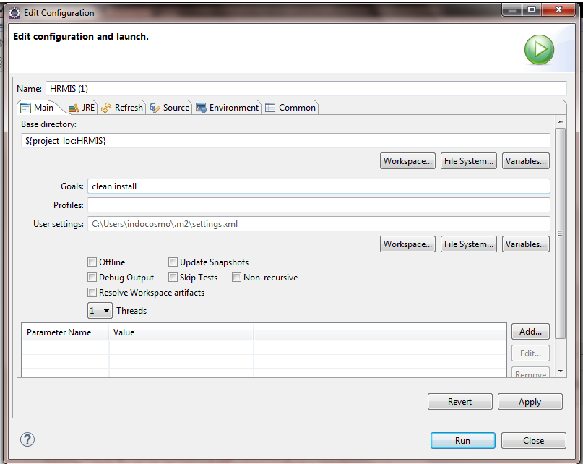

then the click apply , run buttons. After building the application you can see “build success” message in the console. The build file will be generated in /target folder.

Application Deployment
For deploying an application, we have to upload the build file to the tomcat’s webapps folder. Tomcat will automatically extract the files immediately. If you done any changes in property file, the you must restart the server to reflect the changes.

Command for restarting the server is “service tomcat8 restart;”. This may vary with your OS where the tomcat is installed.

DB Structure
This section describes the structure about the database of “HRMIS”.

Tables
“hrmis” database have various number of tables, stored procedure and a function which will be described in the following.

- employee : To store employee personal and professional details including authentication
- approver_tbl : To map each and every approvers to employees and theitr levels
- child : To store the child details of every employee
- client_project_tbl : To store the projects in various clients
- client_tbl : To store the details of clients
- designation : To store the designations
- education : To store the education details of every employee
- holiday_date : To store the details of exact holidays with dates
- holiday_tbl : To store the holiday generalisation(ex:ICS Holidays)
- hrmis_announcement_tbl : To store the announcement details
- hrmis_leave_application_tbl : To store each leave application details whren it is applied
- hrmis_leave_history_tbl : To store the history of each application process
- leave_status : To store the flags related to leave status
- leaveallocation_tbl : To store the details regarding leave allocation
- leavetype_tbl : To store the details of leave types
- location : To store the locations
- personal : To store the personal details of employees
- profession : To store the professional details of employees
- project_manaqger_tbl : To store project managers
- sibling : To store siblings of employees
- work_report_tbl : To store work details of employees

For more structure and details of the database. Refer SDD of the “HRMIS” and hrmis.sql is the database script file to create and setup a new database for HRMIS.

Code Structure
This section refers the structure of coding

Java Code
Following path will lead to the java codes directory.
HRMIS->src->main->java->com->indocosmo->hrmis->
There are 3 types of main directories which are
- Bean : Used to store the bean classes.(classes used to pass values through getters and setters)
- Controller : Used to store controll classes(classes used to connect between database connection codes and UI.
- Dao : Used to store UI and database value transmission codes.

UI code
This section refers the user interface codes of “HRMIS”.

UI codes of the “HRMIS” are stored in HRMIS->src->main->webapp->

- Resources : This directory has commonly used UI elements such as css files,fonts,scripts and images including the dash board and sidebar of both modules(admin&employee).
- WEB-INF : This directory has the main elements such as every page designs which are coded in jsp files including the most important xml files.

